71. From paragraph one, what was Daniel looking forward to? [1m]

72. Look at the table below. What do the words In the left column refer to In the  
passage? Write your answers in the column on the right. [2m]

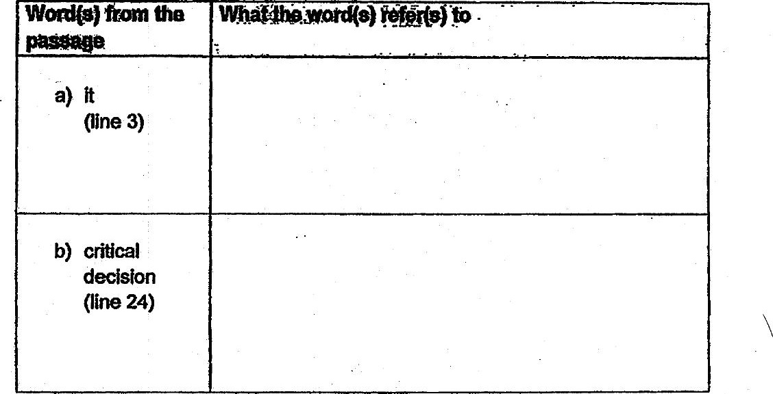

73. . Fill in the table by identifying the correct word from the passage. [2m|

